# [Did Stabler Admit He's In Love With Benson? 'Law & Order' Fans React (today.com)](https://www.today.com/popculture/tv/elliot-stabler-admit-love-olivia-benson-law-and-order-organized-crime-rcna57836?cid=sm_npd_td_tw_ma) Did Stabler just admit he’s in love with Benson? ‘Law & Order’ fans are reeling

This was the most — single most — important scene fans of the beloved "Law & Order" duo have had in a while.

00:01 /04:58

TAP TO UNMUTE

Nov. 18, 2022, 1:51 PM -02 / Source: TODAY

By MC Suhocki

Christmas is still over one month away, but fans of [Capt. Olivia Benson (Mariska Hargitay) and Detective Elliot Stabler (Chris Meloni)](https://www.today.com/popculture/tv/olivia-benson-elliot-stabler-relationship-timeline-law-and-order-svu-rcna37289) have already received quite a gift in the form of an unexpected confession from Stabler on the latest episode of "Law & Order: Organized Crime."

The confession itself wasn't exactly a surprise, but the circumstances and setup were.

Last week, Stabler bumped into an old acquaintance, Tia Leonetti (Ayelet Zurer), during a case. Stabler worked with Leonetti while in Italy, where he and his family relocated after he left the Special Victims Unit and his longtime partner, Benson, over 10 years ago.

From the start, Leonetti shared obvious similarities with [Benson](https://www.today.com/popculture/tv/mariska-hargitay-importance-svu-addressing-olivia-bensons-trauma-rcna48495), like her blazers and her dark, wavy hair. She also seemed to know Stabler pretty well — so well that Stabler's wife, Kathy, who died when she and her husband came back to New York in Stabler's return "SVU" episode in April 2021, "loved" her too. Stabler also mentioned at one point Leonetti supported him when he considered leaving police work while overseas.

The Nov. 10 episode, "All That Glitters," ends with Leonetti calling Stabler, who is at home sipping on a drink late at night after the squad's big bust. Leonetti tells him it "felt good working as a team again" and that he was part of the reason she would "stick around" and not rush back to Italy. Then she shows up outside Stabler's apartment late at night, and Stabler slowly approaches the door and hesitates as Leonetti asks if he'll let her in.

Cue seven days of fan pandemonium: Would Stabler open the door?

Well, taking a step back for a minute, Zurer had shared [an Instagram post](https://www.instagram.com/p/Cj3IVkVOM-k/?hl=en) with photos of her and Meloni with the caption: "More than meets the eye :))" Remember the title of the Nov. 10 episode: "All That Glitters"? As the famous expression goes, "All that glitters is not gold," basically means something shiny or even new isn't as valuable as it appears, or, looks can be deceiving.

While it *looked* like Stabler could very well open the door, take the bait and possibly sleep with his former Italian cohort, the beginning of the Nov. 17 episode, "Whipping Post," proved the Stabler doubters wrong and showed that, yes, there was a lot more going on with the situation than "met the eye."

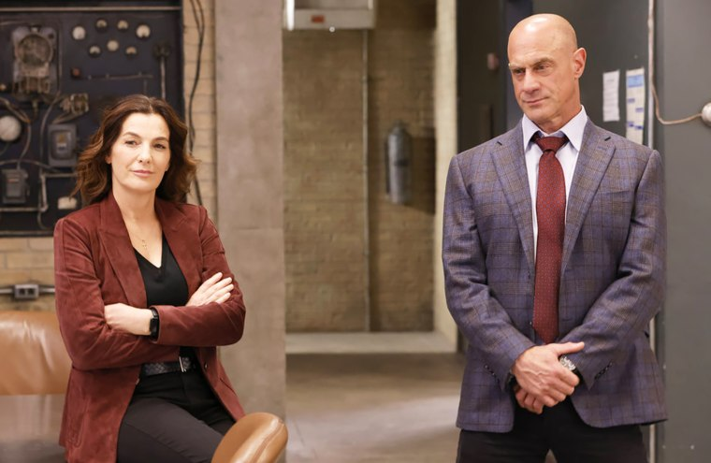Tia Leonetti, you'll always be famous.Will Hart / NBC

Since Stabler returned to New York last year, he's shared a few moments with Benson, including [meeting her son, Noah,](https://www.today.com/popculture/tv/elliot-stabler-met-olivia-bensons-son-law-order-svu-rcna27628) and asking to hang out with them twice. Benson also supported her former partner through the loss of his wife and was by his side when his youngest child went missing, which led to [the handhold](https://www.today.com/popculture/svu-fans-are-freaking-out-over-benson-stabler-moment-new-t239190) felt around the world. Many longtime fans hoping for Benson and Stabler to *finally* get together romantically took these as signs the two former partners were, albeit slowly, building toward just that.

For anyone "shipping" Benson and Stabler, the beginning of "Whipping Post" may have come as a fright. The evidence of a fling with Leonetti was everywhere: Leonetti strolling into the kitchen as Stabler prepares breakfast, shot glasses lining the counter.

However, the fear that Stabler had hooked up with Leonetti was short-lived because she asks him if he felt OK sleeping on the couch.

"I sleep there all the time," Stabler responds. "It was fine."

After commiserating over how much grappa they drank the previous night, Leonetti remembers "some things" — "the important parts, I guess you know, except her name." (Cue audience gasps).

"Whose name?" Stabler asks.

"You said there's a woman you're in love with," Leonetti responds.

A stunned Stabler stares and tries his best to remember before saying, "I did?"

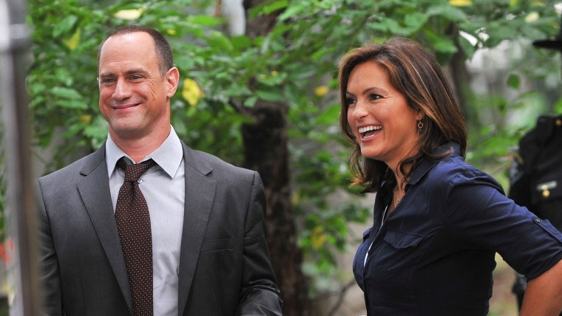

## [Mariska Hargitay: Benson has 'been in love' with Stabler ‘for many a year’](https://www.today.com/video/mariska-hargitay-benson-has-been-in-love-with-stabler-for-many-a-year-131284549616)

JAN. 20, 202201:30

Then he almost nervously goes back to buttering his toast.

### *Recommended*



### [GIFT GUIDES](https://www.today.com/shop/gift-guide)[61 gifts that 18-year-olds will appreciate and be excited to use](https://www.today.com/shop/best-gifts-18-year-old-t241898)



### [LIFESTYLE & FITNESS](https://www.today.com/shop/lifestyle-fitness)[Durable and dry, these 11 hiking boots are ample for braving winter weather](https://www.today.com/shop/best-winter-hiking-boots-2022-t270638)

Leonetti grabs his arm and says, "Love shouldn't be complicated. Love affairs? Yes, they can get messy, but love — that's different."

"I'm happy for you," she adds.

Fans on Twitter couldn't get enough of the plot twist.

Circling back to why Stabler's drunken admission wasn't a surprise. In Season One of "Organized Crime," [Stabler said "I love you" while staring at Benson](https://www.today.com/popculture/stabler-benson-shared-moment-svu-fans-have-been-waiting-decades-t216178) in the middle of a tense intervention staged by his children, who wanted Benson there for the meeting as well.

The closest we've gotten since that scene to an explanation was a mysterious voicemail Stabler attempted to leave Benson before a dangerous meeting that he knew could end in death. In Season Two's episode "For A Few Lekë More," Stabler calls Benson and records a message thanking her for being his "rock." He concludes, "And when I said that ‘I love you,’ I think you —" but is cut off by an automated recording asking if he wants to redo the message. Did Benson receive the message? We still don't know.

The conversation in the kitchen with Leonetti is hardly Stabler's first clocking on [his feelings for Benson](https://www.today.com/popculture/tv/law-order-star-chris-meloni-talks-stablers-feelings-benson-rcna16658).

Former "OC" villain Richard Wheatley hinted during a scene with Stabler that there's "another woman who's the one true love" of Stabler's life.

And in Season Two's premiere episode, a woman read Stabler's coffee grounds and came away with the message: "She wants to know why you don’t tell her how you feel."

"Why I don’t tell her how I feel?" Stabler asks.

"The person you love."

Later in the episode while saying goodbye to Stabler, Leonetti says, "Whoever it is you're in love with, she's a lucky woman."

Stabler telling the woman he's in love with that he loves her when?Will Hart / NBC

Over on "SVU" in last season's finale, Benson's therapist brought up Stabler and encouraged her to explore a romance with him or to move on. In the same episode, Benson's friend and detective Amanda Rollins implied she and Stabler should get a hotel room to get whatever's building between them out of their systems.

It's also worth noting at the end of the Nov. 17 episode of "SVU," "A Better Person," Rollins and Benson toasted "to love." Then, "Organized Crime" begins immediately after and we hear about Stabler's drunken love confession? Hmm, thinking thoughts!

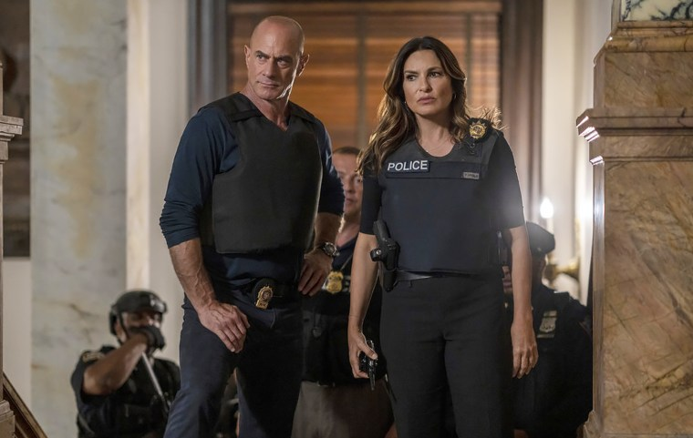Respectively asking they be brought back to us in the same scene.Zach Dilgard / NBC

Viewers haven't seen Benson and Stabler share the screen since [this season's huge premiere event](https://www.today.com/popculture/tv/law-order-brings-3-casts-together-first-time-historic-crossover-rcna44435), which was a crossover among [all three "Law & Order" shows](https://www.today.com/popculture/tv/law-order-women-collaborating-crossover-premiere-rcna48756).

Will we see them together before the year ends? Christmas was certainly [a special time for Benson and Stabler last year](https://www.today.com/popculture/benson-stabler-got-personal-law-order-christmas-crossover-t242774). While helping Stabler locate his son, Eli, and helping clear Eli of a crime, Stabler *finally* asked Benson about her life during his 10-year absence, specifically if she was seeing anyone, and ended the episode by inviting her and Noah over for Christmas. The scene also established the two were friends — "for now."

"SVU" and "Organized Crime" return in three weeks before a Christmas break, and we are asking for just one gift this year: That these two cross paths again this holiday season!

*"Law & Order: Organized Crime" returns Dec. 8 at 10 p.m. after new episodes of "Law & Order" and "Law & Order: SVU" at 8 p.m. and 9 p.m. on NBC.*